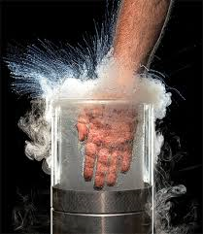Come for a Fun Night Out!
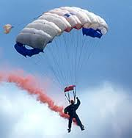
Family Science Show

Air: Invisible yet so Effective

Monday August 14, 2017
7.00 p.m. – 8.00 p.m.

St Therese’s School, Bentley Park

For Keen Science Students (Primary and Secondary) and Parents/Guardians

Increase your Interest and Enjoyment in Learning

- Study air as an occupier of space, objects falling in air compared with in a vacuum, the particle model of matter, pressure, expansion and contraction, and phase changes while also addressing common misconceptions.

Highly Visual and Entertaining

- See the refusing funnel, objects released in a vacuum, a suspended student (and a parent!), expanding and shrinking balloons, a frozen squash ball break, a tin explode, and more, plus make a cloud.

Examine Interesting Phenomena Using Equipment That is Not Readily Available

- Use novel equipment that includes vacuum pump, other vacuum apparatus, and liquid nitrogen.
Cost: $10 per person or $25 Family Pass

Presenter: Dr Peter H. Eastwell
Director, Science Time Education (www.ScienceTime.com.au)

To Book

To book, please email the name(s) of those in your group wishing to attend, as well as the name of your school, to therese@sciencetime.com.au by August 10. You will receive confirmation of your booking by return email. Payment will be by cash ($12 per person) at the door on the night, please. Booking is important to ensure that the show is not overbooked or that you are alerted in the event that bookings are insufficient to support the show.

