Come for an Electrifying Night Out!

Family Science Show

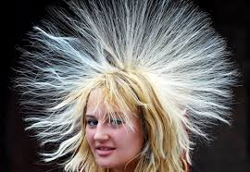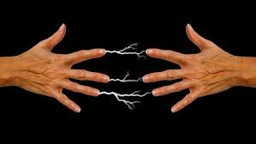Electricity: A Shocking Experience

Monday October 31, 2016
5.45 p.m. – 6.45 p.m.

Leaning Tree Community School,
Geraldton

For Keen Science Students (Primary and Secondary) and Parents/Guardians

Increase your Interest and Enjoyment in Learning

- Who invented electricity? What causes static electricity? What is the difference between volts and amps? Which one is deadly? What is the difference between AC and DC? How are radio waves and x-rays made?

Highly Visual and Entertaining

- See the behaviour of charged objects, 400 000-volt Van de Graaff generator, human body conducting electricity, long sparks from a one-half-million-volt Tesla coil, St. Elmo's fire, current in special gases, transmission of electrical energy without wires, and the effect of electricity on your muscles (ouch!).

Examine Interesting Phenomena Using Equipment That is Not Readily Available

- Study the nature of electricity, the significance of a high voltage sign, different ways to produce electric currents, conductors and insulators, electrical safety, and appreciate the contribution of electricity to our social and economic well-being. And more.

Cost: $12 per person.

Presenter: Dr Peter H. Eastwell
Director, Science Time Education (www.ScienceTime.com.au)

To Book

To book, please email the name(s) of those in your group wishing to attend, as well as the name of your school, to leaning@sciencetime.com.au by October 27. You will receive confirmation of your booking by return email. Payment will be by cash ($12 per person) at the door on the night, please. Booking is important to ensure that the show is not overbooked or that you are alerted in the event that bookings are insufficient to support the show.

