Come for a Shocking Night Out!

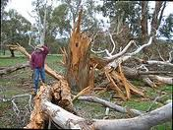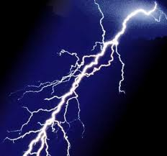Family Science Show

Lightning: So Frightening

Thursday March 15, 2018
7.00 p.m. – 8.00 p.m.

Franklin Public School, Tumut

For Keen Science Students (Primary and Secondary) and Parents/Guardians

Increase your Interest and Enjoyment in Learning

- What is the difference between volts and amps? Which one is deadly? Does a lightning flash travel upwards or downwards? Why shouldn’t you lie down on the ground when there is a thunder storm around? Why do so many people die unnecessarily after an electrical accident or being struck by lightning? And more.

Highly Visual and Entertaining

- See the long sparks from a one-half-million-volt Tesla coil, the effect of electricity on your muscles (ouch!), how lightning caused an Italian church to explode, what happens when lightning strikes a car, and more, and hear some fascinating stories involving lightning.

Examine Interesting Phenomena Using Equipment That is Not Readily Available

- Study different types of lightning strikes to people and other animals, ways to protect yourself from being struck by lightning, why lightning can affect different types of trees in different ways, and more.

Cost: $12 per person.

Presenter: Dr Peter H. Eastwell
Director, Science Time Education (www.ScienceTime.com.au)

To Book

To book, please email the name(s) of those in your group wishing to attend, as well as the name of your school, to tumut@sciencetime.com.au by March 13. You will receive confirmation of your booking by return email. Payment will be by cash ($12 per person) at the door on the night, please. Booking is important to ensure that the show is not overbooked or that you are alerted in the event that bookings are insufficient to support the show.

